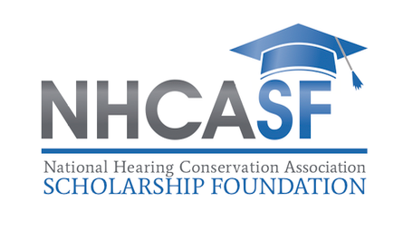

NATIONAL HEARING CONSERVATION ASSOCIATION SCHOLARSHIP FOUNDATION

RECOMMENDATION FORM FOR STUDENT RESEARCH AWARD

Note: This Form Should be Typed or Written Legibly
PLEASE RETURN THIS RECOMMENDATION FORM BY September 20, 2019

Applicant’s Name:

Address:

Phone:
Email:

TO THE APPLICANT: You should give a copy of this Recommendation Form to two (2) individuals
(preferably faculty) who can speak to your student status, performance, and potential.

Under the Family Educational Rights and Privacy Act of 1974, a student has access to his/her educational records. If the student wishes to waive the right to examine his/her reference report, please sign below:

Signature

TO THE RECOMMENDER: The Student Research Award of the National Hearing Conservation Association Scholarship Foundation is intended for exceptional graduate students who are working toward a degree in one of the fields associated with hearing loss prevention/hearing conservation (e.g., education and motivation, sound surveys, engineering/administrative controls, hearing protection, audiometric testing).

Recommendations are a key part of the applicant’s dossier. Please judge the applicant’s capabilities and research accomplishments against all students you have taught or worked with in the area of hearing loss prevention/hearing conservation.

Awards will be based on the following general considerations:

(1) The potential for the student to make a significant contribution related to hearing loss prevention/hearing conservation in society,

(2) Demonstrated academic and research accomplishment and intellectual ability,

(3) Applicant’s character, school and community activities, personal motivation, and leadership potential,

(4) Present or past activities either as a member of a local student or national professional society, and

(5) Potential benefit of the student’s completed thesis, dissertation or special project

REVIEWER’S RESPONSE

1. How well, in what relationship and how long have you known the Applicant?

2. Please rank the Applicant on the following traits in comparison with other students of your acquaintance at the same level of experience and training:

UNABLE
TO HIGHEST HIGHER MIDDLE LOW LOWEST EVALUATEE 10% 20% 40% 20% 10%

Intellectual
Ability

Efficacy of Written
Expression

Motivation/ Perseverance

Ability to Work
With Others

Potential as a
Leader

Originality/ Creativity

3. Please comment concerning strengths and weaknesses of the applicant.

4. Give your opinion of the applicant’s academic ability and promise for future applied research

RECOMMENDATION: (check one)

The applicant has my highest recommendation.
I recommend the applicant with confidence.
I recommend the applicant with some reservations.
I do not recommend the applicant.

Signature Date

Name of reviewer (print or type)

Phone Number

PLEASE RETURN THIS RECOMMENDATION FORM BY
September 20, 2019

